**Initial word frequency**

Word cloud and a bar chart showing what people are saying in their answer to this question

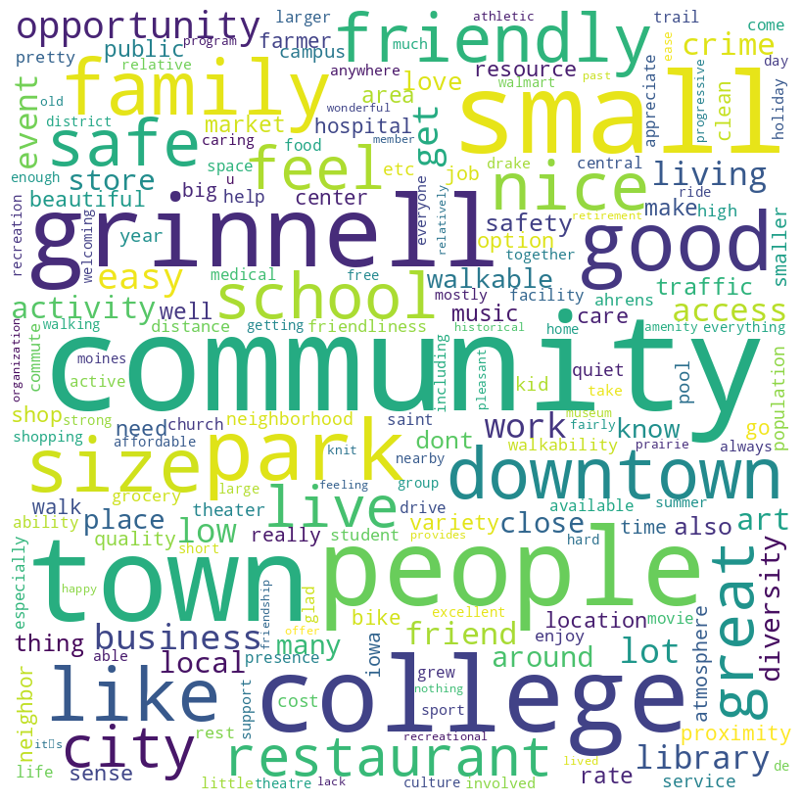

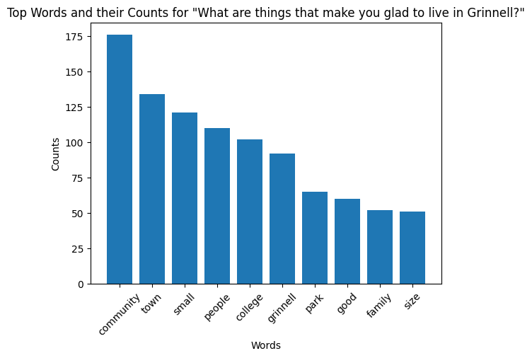

**Words before after a word**

Visuals highlighting words that appear after or before a certain word, in this case “community”

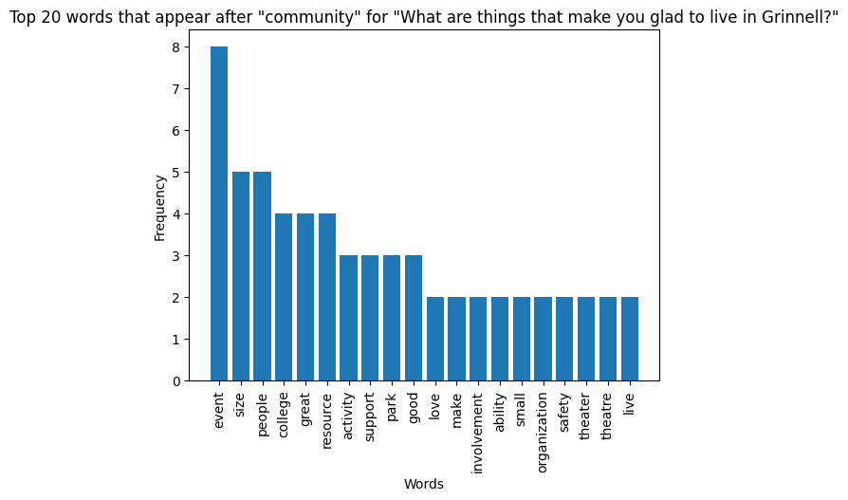

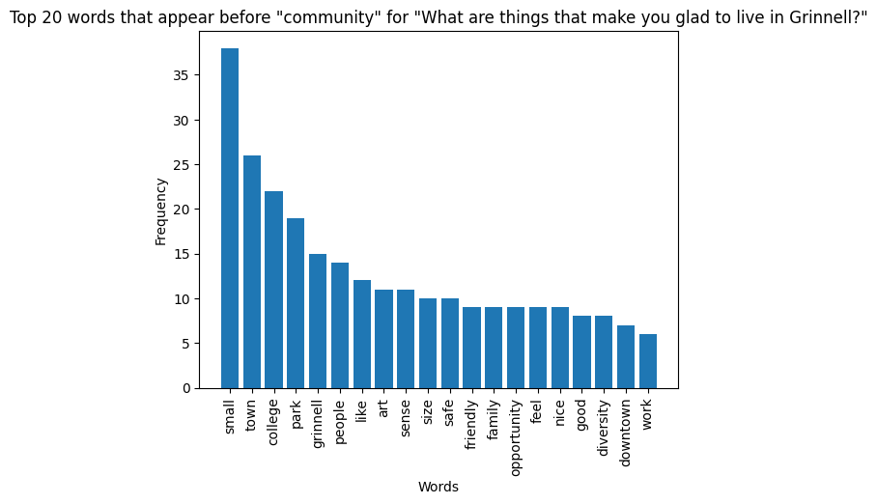

2 words after the word community Excel file output snapshot:

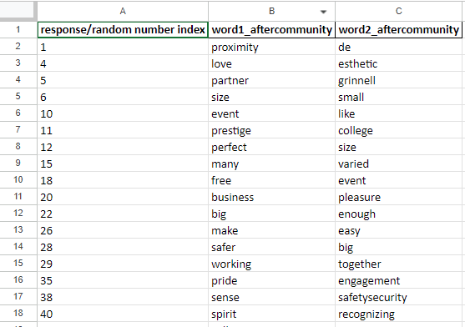

**For the full excel file, navigate to Final Deliverable > Individual Question Analysis & Deliverables > Words after common word > aftercommunity.xlsx (Excel file)**

**Sentiment Analysis**

Numbers on how many people were positive, negative, or neutral in their responses.

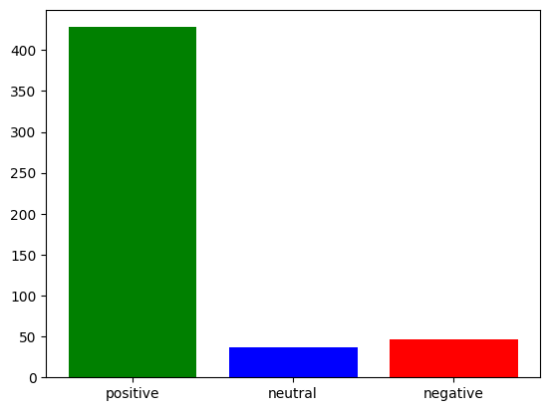

The number of **positive** statements is 428

The number of **negative** statements is 46

The number of **neutral** statements is 37

**Snapshot of which rows are in which category** (only part of the output):

